# OneWireViewer and IButton Guide

## Introduction

Maxim's iButton products are designed for straightforward integration with Windows PCs via USB. The OneWireViewer software, essential for interfacing with iButtons, requires the Java JRE, which is available from Oracle or other sources. This program, along with the necessary drivers, is freely downloadable. It supports Windows versions including 10, 7, Vista, and XP. The accompanying application note offers comprehensive installation guidance for these specific operating systems, ensuring a seamless setup process.

## Getting Started

To communicate with your iButton, you need all the items depicted below.

|  |
| --- |
|  |

Required setup components.

Maxim provides two iButton kits, including the adapter, reader, and iButton for evaluation: DS1921K# - iButton Temperature Logger Starter Kit.

## Step 1. Java installation

To verify if your PC has Java installed or to check the installed version, open the command prompt and type "java -version". This command will reveal if Java is present and its version number, ensuring compatibility with the OneWireViewer, which requires Java 6 or higher. This step is crucial as many PCs come with Java pre-installed.

To access the command line in Windows, search for 'Command Prompt' in the Start menu or press 'Windows Key + R' to open the Run dialog. Type 'cmd' and press Enter. This will launch the Command Prompt, where you can type "java -version" to check your Java installation and version.

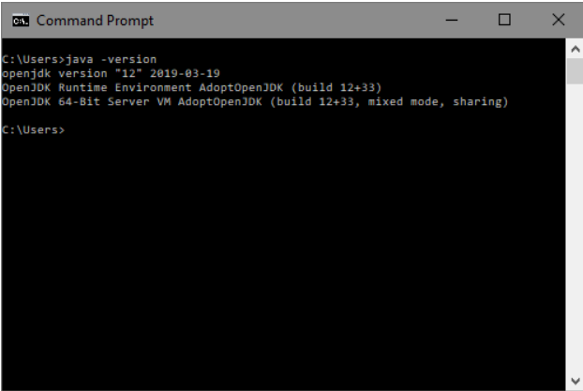

If Java 6 or higher is not installed on your PC, you can download it from Oracle's official website. Navigate to Oracle's Java download page, select the appropriate Java version for your operating system, and follow the provided installation instructions. This process typically involves downloading an executable file and running it, which guides you through the installation steps. Ensure you download a version that is Java 6 or newer to meet the requirements of the OneWireViewer software. Here is the site: <https://www.java.com/download/ie_manual.jsp>

## Step 2. Download bundled OneWireViewer and 1-Wire drivers

NOTE: DO NOT INSERT THE USB ADAPTER INTO THE PC YET. THIS SHOULD NOT BE DONE UNTIL STEP 4, AND WILL USUALLY CAUSE INSTALATION PROBLEM IF DONE BEFORE STEP 4.

Download the bundled OneWireViewer and 1-Wire drivers [here](https://www.maximintegrated.com/en/1-Wiredrivers). The website includes menus to assist in selecting the correct file for your PC's operating system. Be aware of the two types of Microsoft operating systems available: 32-bit and 64-bit. It's important to choose the version that corresponds to your computer's architecture to ensure compatibility and proper functioning of the software.

<https://www.analog.com/en/design-center/evaluation-hardware-and-software/1-wire-sdks/sdk-windows.html>

## Step 3. Installing bundled OneWireViewer and 1-Wire drivers

After completing step 2, run the file to start the installation.

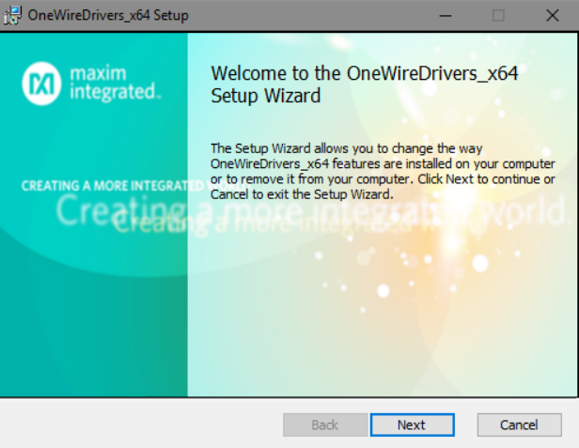

After this, you are prompted to accept the license agreement if you choose to use the 1-Wire drivers and the OneWireViewer software.



End-user license agreement.

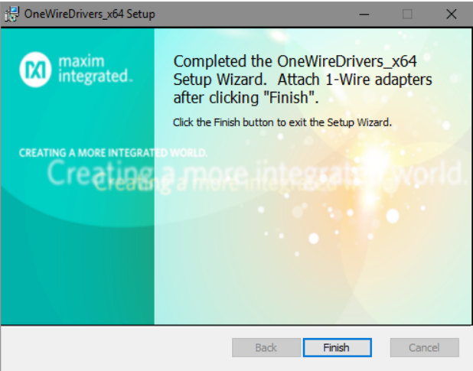

Finish installation.

After installation completes, click the Finish button to complete the installation.

## Step 4. Complete USB installation

Now connect the DS9490R# USB adapter into your PC, as shown below.

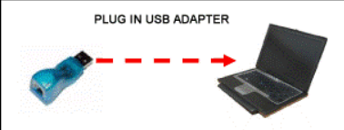

## Step 5. Start the OneWireViewer program

Follow these steps to launch the OneWireViewer:

1. Click the Windows button
2. Click on the “1-Wire Drivers” folder.
3. Click on OneWireViewer.jar.

## Step 6. Connect the iButton and the reader

Next, snap the iButton into one of the blue dots on the reader and plug the reader into the adapter. The 1-Wire communication protocol can read multiple devices on the network at the same time.

Connect an iButton to the reader by snapping it into place.

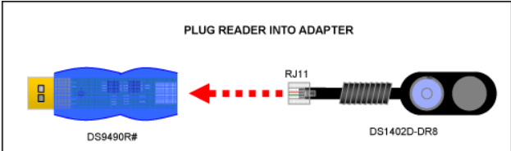

Connect the reader to the adapter.

## Step 7. Run the OneWireViewer

The OneWireViewer is versatile, compatible with all iButton versions, including Hygrochron and Thermochron temperature loggers, memory iButtons, and identification iButtons. It's an open-source program, providing a solid foundation for software developers to build custom applications tailored to their specific needs

## Problem solving

If you encounter problems getting the OneWireViewer to work, please file a support request using the [Tech Support](https://www.maximintegrated.com/en/ibutton) form.

More Information

For Technical Support: https://www.maximintegrated.com/en/support

For Samples: https://www.maximintegrated.com/en/samples